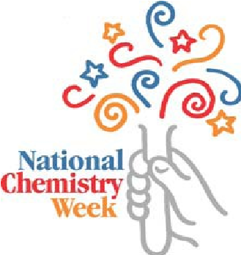

**ChemExpo 2017**

**Saturday, October 21, 2017**

**Call for Sponsorship**

On Saturday October 21st, the North Jersey Section of ACS will be holding its 23rd ChemExpo in celebration of NCW (National Chemistry Week) at Liberty Science Center, Newark, New Jersey. Please help us make a difference! The theme for this year is "**Chemistry Rocks”**.

We are looking forward to financial support to help cover many of the expenses associated with the Section’s NCW activities. A donation of $500.00 indicates Gold Sponsorship, a $250.00 gift indicates Silver Sponsorship and a $100.00 gift indicates a Bronze Sponsorship. We would appreciate it if you would forward this information to the appropriate representatives within your company.

Checks should be made out to:

“NJACS” (The North Jersey Section of American Chemical Society) with a memo of “NCW”.

Sent to:

Jacqueline Erickson

33 Ronald Road

Lake Hiawatha, NJ, 07034-1121.

Thanks very much for all of your help. The Section is most appreciative of your efforts.

Mita Chaki and Monica Sekharan

Please fill out the information below and return the form to Bobbi Gorman at rosellerams@yahoo.com.

# Sponsorship Form

**My company would like to support these efforts at the _____________ (indicate gold, silver, or bronze) level.**

**Name of the Company:**

The following company/individuals are willing to help defray the costs of these events:

An acknowledgement letter for this contribution should be sent to: Name:

Email:

Full address: