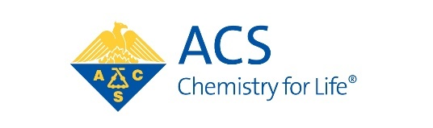
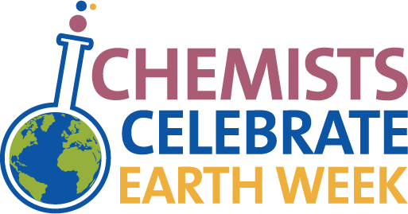

Chemists Celebrate Earth Week (CCEW) Illustrated Poem Contest
ENTRY FORM

DO NOT PUT YOUR NAME ON YOUR ILLUSTRATED POEM
Please fill out this form and attach it after the poem. All fields are required. Incomplete forms will invalidate
the entry.

The deadline for the North Jersey Local Section Contest is April 30, 2023.

Submit poems to : Dr Kathleen Gilbert Email: kgilbert@njacs.org

Student and Organization Information
Student Name:
Student Email:
Student Grade:
Parent/Guardian Name:
Parent/Guardian Email:
Parent/Guardian Address:
Parent/GuardianCity: |  |  |  | State: | Zip:
School or Sponsoring Group (e.g. Boys
and Girls Club or Scout Troop, 4H, etc):
Teacher Name:
Teacher Email:
School Name:
School Address:
School City: |  |  |  | State: | Zip:
Please send any follow up for the student to the or address
Illustration Type (Check one)
If the poem was digitally created, please name the software used in the box below:
Judging Category by Grade (Check 1)
FOR LOCAL SECTION USE ONLY
Local Section Name: |  | North Jersey
CCEW Coordinator Name: |  | Dr. Kathleen Gilbert
CCEW Coordinator Email/Phone: |  | kgilbert@njacs.org

More information is available at www.acs.org/ccew.

